**Praktikum 10A**

* Source Code

Program **Praktikum10A**;

Var

    A: array[0..9] of Real;

    B: array[-10..20] of String;

    C: array['a'..'j'] of Boolean;

    X : array[1..10] of Integer;

begin

    X[1] := 10;

    X[2] := X[1] - 5;

    X[3] := X[2] + X[1];

**Writeln**(X[3]);

**Writeln**(X[13]);

**Writeln**(A[10]);

end.

* Output

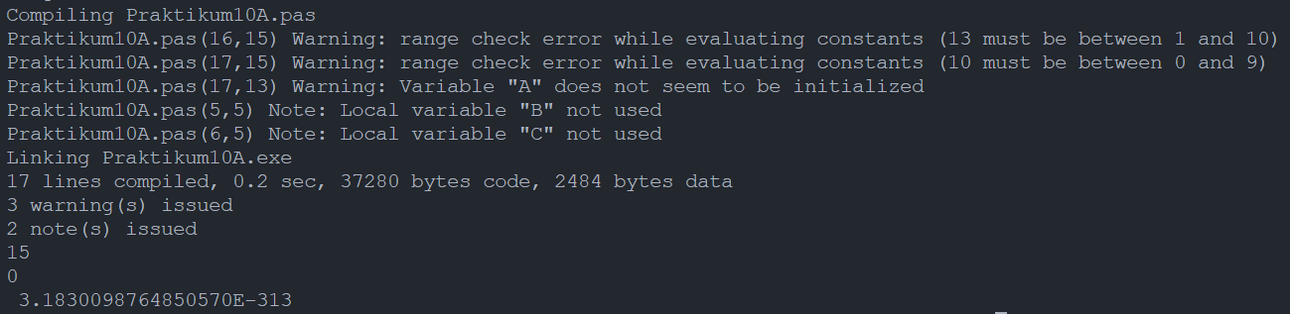

Penjelasan : Walaupun program bisa berjalan di compiler yang saya pakai, namun muncul warning *out of index* pada line 16 dan 17 karena di line 16 menggunakan index ke 13 padahal array hanya berisi 10 index dan di line 16 menggunakan index ke 10 padahal array hanya berisi 9 index.

**Praktikum 10B**

* Source Code

Program **Praktikum10B**;

Var

    X : array[1..10] of Integer;

    Terbesar: Integer;

    i : Integer;

Begin

    For i:=1 to 10 do Begin

**Write**('Input data ke-', i,'= ');

**Readln**(X[i]);

    End;

    Terbesar := X[1];

    For i:=2 to 10 do Begin

        If X[i] > Terbesar then Terbesar := X[i];

    End;

**Writeln**(Terbesar);

    Readln;

End.

* Output

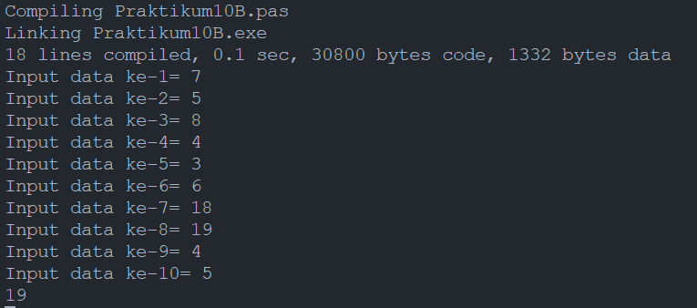

Penjelasan :

Program berjalan dengan menganggap elemen index pertama dari array sebagai bilangan terbesar, lalu dibandingkan dengan elemen setelahnya. Jika elemen index pertama lebih besar dari elemen index setelahnya, maka variabel terbesar masih diisi dengan elemen pertama. Tetapi, jika elemen pertema lebih kecil dari elemen index setelahnya, maka variabel terbesar diisi dengan elemen setelahnya. Begitu seterusnya sampai index ke 10.

**Praktikum 10C**

* Source Code

Program **penjum_matriks**;

var

    a,b,c: array[1..3, 1..3] of integer;

    i,j: integer;

begin

**writeln**('buat matriks A');

    for i:=1 to 3 do

        for j:=1 to 3 do begin

**write**('[',i,',',j,']=');

**readln**(a[i,j]);

        end;

**writeln**('buat matriks B');

    for i:=1 to 3 do

        for j:=1 to 3 do begin

**write**('[',i,',',j,']=');

**readln**(b[i,j]);

        end;

**writeln**('Matriks A');

    for i:=1 to 3 do begin

        for j:=1 to 3 do

**write**(a[i,j]:3,' ');

            writeln;

        end;

**writeln**('Matriks B');

    for i:=1 to 3 do begin

        for j:=1 to 3 do

**write**(b[i,j]:3,' ');

        writeln;

    end;

**writeln**('Matriks C');

    for i := 1 to 3 do begin

        for j := 1 to 3 do begin

            c[i][j] := a[i][j] + b[i][j];

**write**(c[i, j]:3, ' ');

        end;

        writeln;

    end;

    readln;

end.

* Output

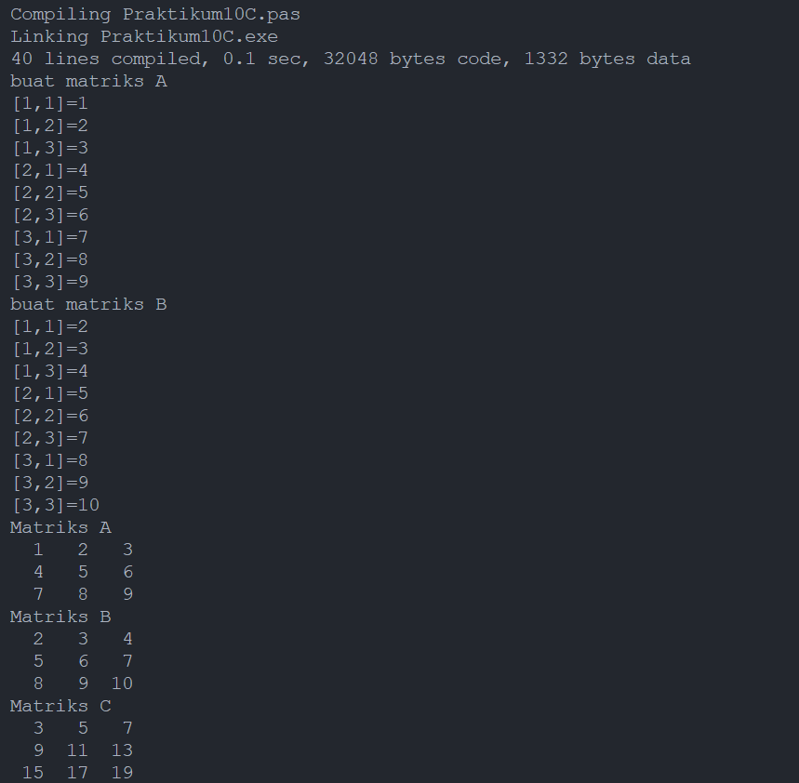

**Praktikum 10D**

* Source Code

Program **penjum_matriks**;

var

    a, b, c: array[1..3, 1..3, 1..3] of integer;

    i, j, k: integer;

begin

**writeln**('buat matriks A');

    for i:=1 to 3 do

        for j:=1 to 3 do

            for k := 1 to 3 do begin

**write**('[', i, ', ', j, ', ', k, '] = ');

**readln**(a[i,j,k]);

            end;

**writeln**('buat matriks B');

    for i:=1 to 3 do

        for j:=1 to 3 do

            for k := 1 to 3 do begin

**write**('[', i, ', ', j, ', ', k, '] = ');

**readln**(b[i,j,k]);

            end;

**writeln**('Matriks A');

    for i := 1 to 3 do

        for j := 1 to 3 do

            for k := 1 to 3 do

**writeln**('A[', i, ', ', j, ', ', k, '] = ', a[i,j,k]);

**writeln**('Matriks B');

    for i:=1 to 3 do

        for j:=1 to 3 do

            for k := 1 to 3 do

**writeln**('B[', i, ', ', j, ', ', k, '] = ', b[i,j,k]);

**writeln**('Matriks C');

    for i := 1 to 3 do

        for j := 1 to 3 do

            for k := 1 to 3 do begin

                c[i][j][k] := a[i][j][k] + b[i][j][k];

**writeln**('C[', i, ', ', j, ', ', k, '] = ', c[i,j,k]);

            end;

    readln;

end.

* Output

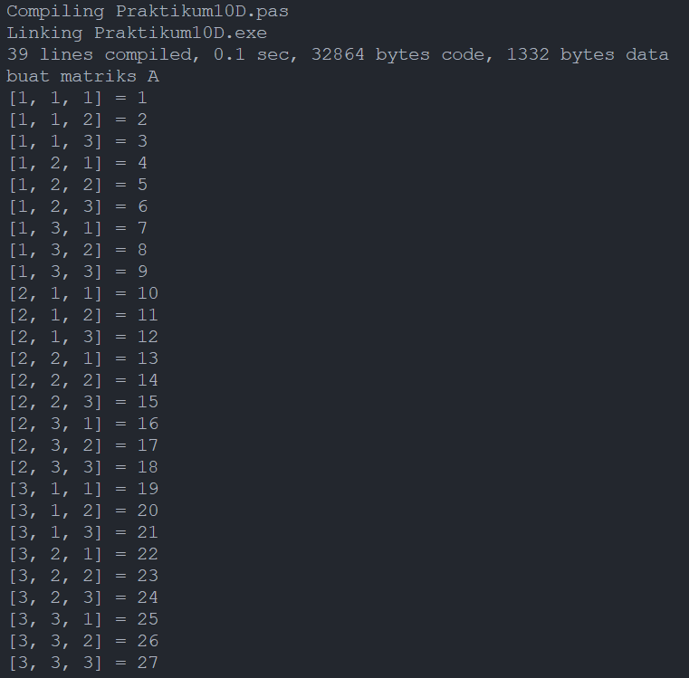

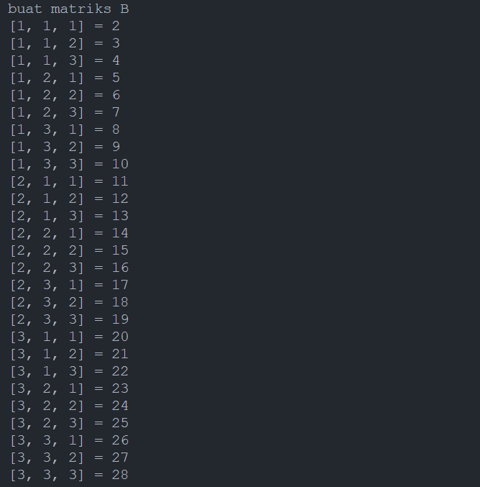

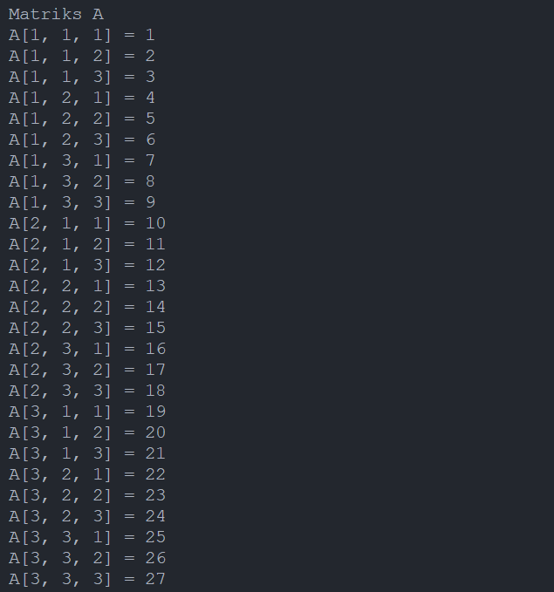

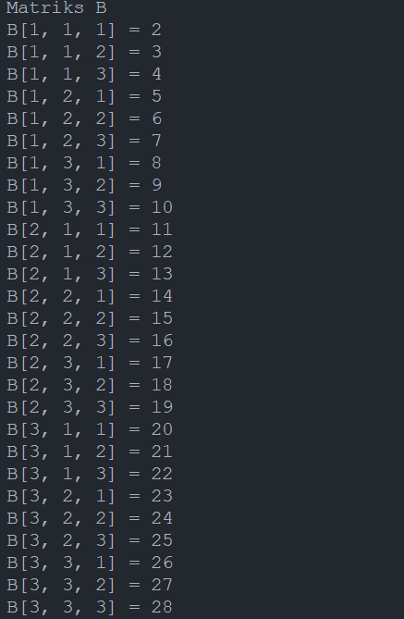

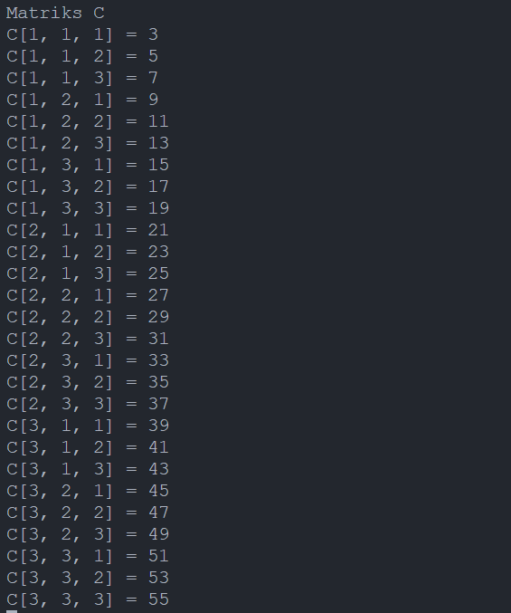

**Praktikum 10E**

* Source Code

Program **penjum_matriks**;

type

    Matrix = array[1..3, 1..3] of real;

var

    a,b,c: Matrix;

    i,j: integer;

begin

**writeln**('buat matriks A');

    for i:=1 to 3 do

        for j:=1 to 3 do begin

**write**('[',i,',',j,']=');

**readln**(a[i,j]);

        end;

**writeln**('buat matriks B');

    for i:=1 to 3 do

        for j:=1 to 3 do begin

**write**('[',i,',',j,']=');

**readln**(b[i,j]);

        end;

**writeln**('Matriks A');

    for i:=1 to 3 do begin

        for j:=1 to 3 do

**write**(a[i,j]:5:2,' ');

            writeln;

        end;

**writeln**('Matriks B');

    for i:=1 to 3 do begin

        for j:=1 to 3 do

**write**(b[i,j]:5:2,' ');

        writeln;

    end;

**writeln**('Matriks C');

    for i := 1 to 3 do begin

        for j := 1 to 3 do begin

            c[i][j] := a[i][j] + b[i][j];

**write**(c[i, j]:5:2, ' ');

        end;

        writeln;

    end;

    readln;

end.

* Output

